**ASSIGNMENT 8**

**1)** **Seven-Segment-Display**

Although Logisim has a hexadecimal display tool you must use the 7-segment display

tool for this exercise. Create a new circuit board to use and design a circuit that translates a 4-bit input to its hexadecimal character on the 7-segment display (see Figure below).

Use the Analyze Circuit dialog to create the truth table for this circuit for all 16 possible combinations of inputs and the 7 outputs.



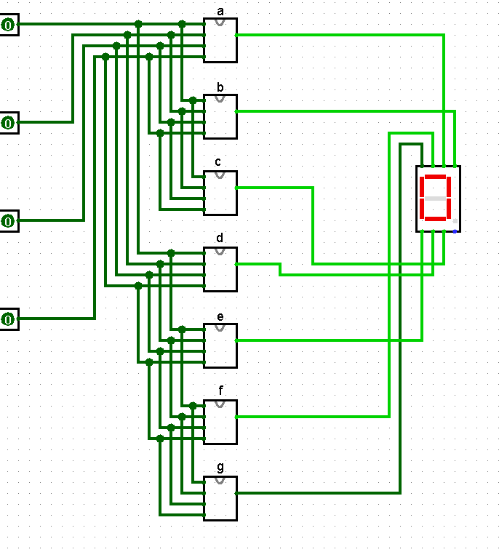

**2)** The **Gray code** – also known as **Cyclic Code**, **Reflected Binary Code** (RBC), **Reflected Binary**(RB) or **Grey code** – is defined as an ordering of the binary number system such that each incremental value can only differ by one bit. In gray code, while traversing from one step to another step only one bit in the code group changes. That is to say that two adjacent code numbers differ from each other by only one bit.

Gray code is the most popular of the unit distance codes, but it is not suitable for arithmetic operations. Gray code has some applications in analog to digital converters, as well as being used for error correction in digital communication. Using the following gray code table design a **binary to gray code converter** circuit.

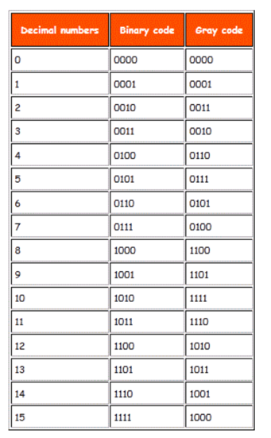

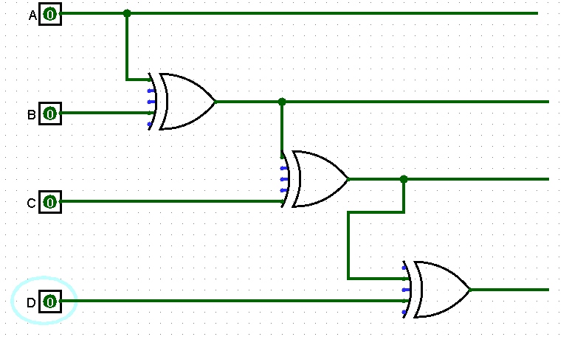

**3)** A combinational circuit is defined by the following three Boolean functions: Design the circuit with a decoder and external OR gates.



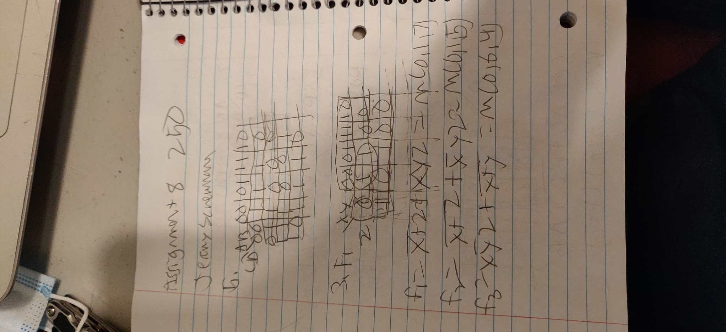

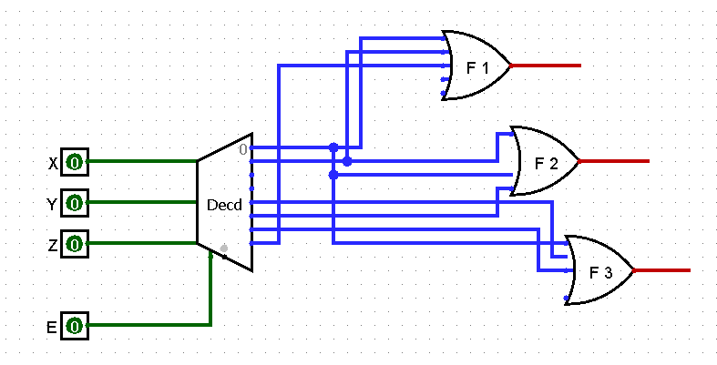

**4)** A combinational circuit is specified by the following three Boolean functions:



Implement the circuit with a decoder and external OR gates

Once again I think I am missing something

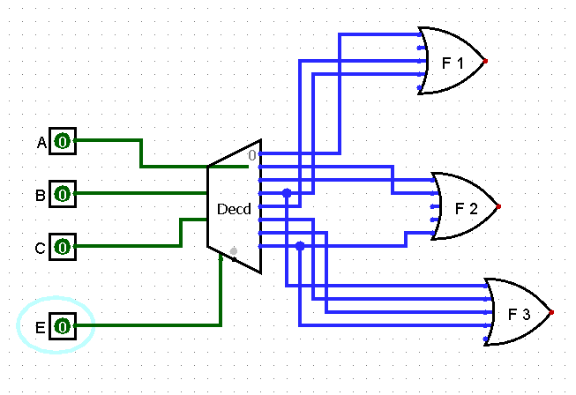

**5)** A combinational circuit is defined with following Boolean function:



Design the circuit with a decoder and external OR gates

I don’t think I configured it right I will have to ask you about this in oh some time

